Crime
Impact Score
0 18 30
Violent crimes consist of murder, rape, robbery, assault, property crime, burglary, larceny, and motor theft. Crimes often influence the safety and wellbeing of a community.

Health Impacts  Increased risk of:  - Injury  - Depression  - Post traumatic stress disorder (PTSD)  - Death  - Negative perceptions of neighborhood safety  Source: WHO World Report on Violence and Health 2002 | Comparison  Violent Crime, Marion Co. vs. other locations, 2016  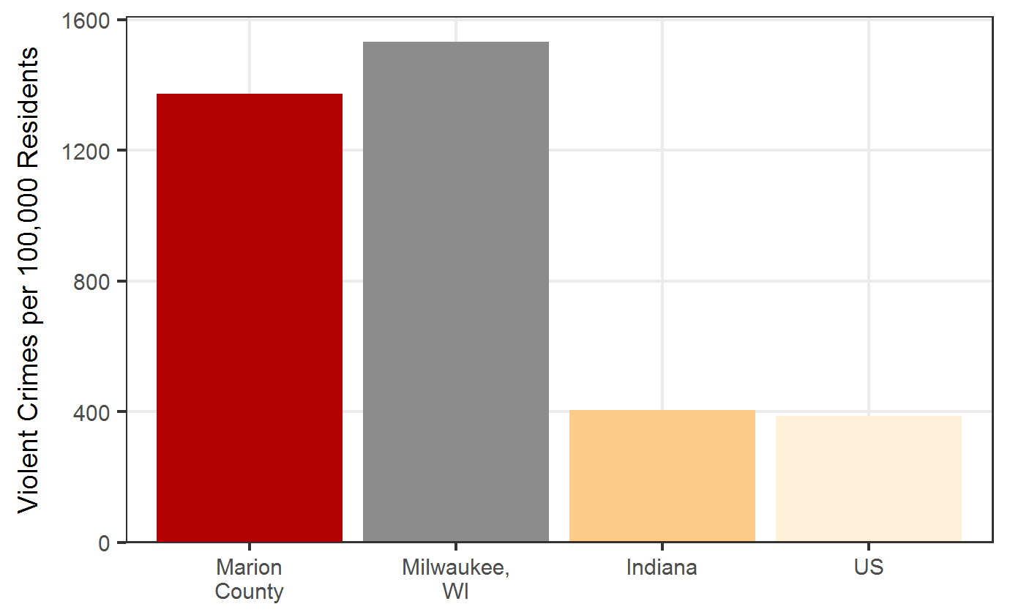  Source: FBI NIBRS

Treatment
- Community building
- Enhancing community resources
- Improve community infrastructure
- Reduce social stressors (e.g. poverty)
Source: WHO World Report on Violence and Health 2002

Trend
Marion Co. Violent Crimes, 2012-2016
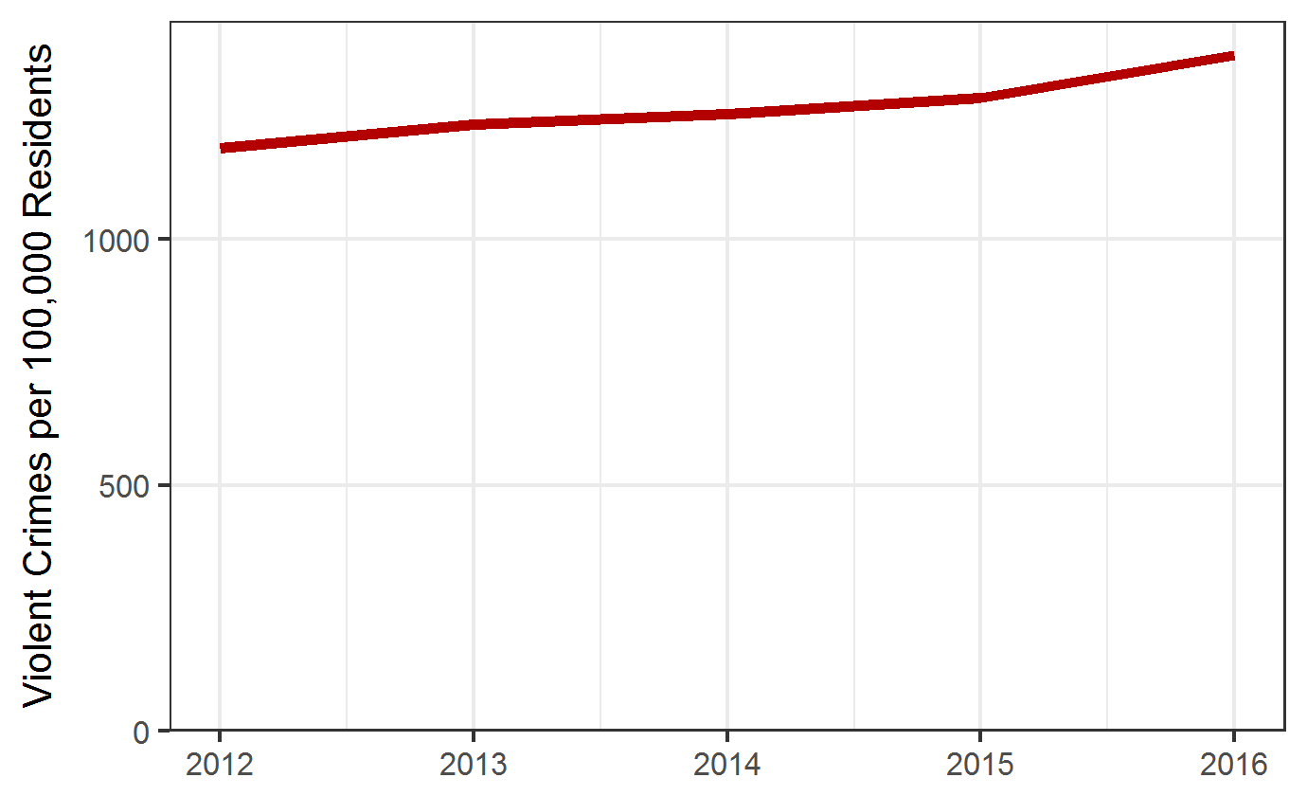
Source: FBI NIBRS

DR3774

Risk Factors

Personal Risk factors  - Past violent behaviors  - Use and abuse of alcohol or drugs  - Bullying  Source: New York State Office of Mental Health |  | Environmental and Community Risk Factors  - Economic disadvantage  - Community disorganization  - Access to guns or other weapons  Source: New York State Office of Mental Health

Equity
Perceptions of Safety by Race  Blacks may be slightly more likely than Whites and Latinos to consider their neighborhood unsafe. | Uncertain Neighborhood Safety by Race, Marion Co. 2018  Source: 2018 Marion County Community Health Assessment Survey
Uncertain Neighborhood Safety by Gender, Marion Co. 2018  Source: 2018 Marion County Community Health Assessment Survey |  |  | Perceptions of Safety by Gender  Women may be slightly more likely than men to consider their neighborhood unsafe.
7

